Elena R. Whitaker | Academic Program Coordinator
Brookfield, Colorado • (970) 555-XXXX • elena.whitaker@enhancv.com

EDUCATION
Bachelor of Science in Education  University of Idaho  Relevant Coursework: Instructional Design, Educational Psychology, Assessment & Evaluation, Learning Technologies | Moscow, ID  2020
Associate of Arts  North Idaho College | Coeur d’Alene, ID  2018
EXPERIENCE
Academic Program Coordinator  Idaho Center for Higher Learning  - Spearheaded curriculum alignment for 5 programs, identifying 12 instructional gaps to ensure 100% compliance with state standards.  - Optimized academic scheduling for 2,500+ students, reducing course conflicts by 25% through a new centralized digital tracker.  - Implemented standardized assessments across 40+ courses, increasing measurable learning outcomes by 15% in one year. | Boise, ID  August 2021 – Present
Instructional Support Specialist  University of Idaho  - Supported 45+ faculty in transitioning 12 programs to online formats while maintaining a 95% faculty satisfaction rating.  - Led LMS migration and updates, resulting in a 30% reduction in technical support tickets through proactive resource design.  - Audited 80+ course modules for institutional standards, achieving 100% ADA accessibility compliance across all digital assets. | Moscow, ID  June 2020 – July 2021
PROJECTS
Curriculum Redesign Initiative  - Description: Comprehensive review and redesign of undergraduate program  - Role: Led curriculum mapping, coordinated faculty workshops  - Technologies used: Canvas LMS, Microsoft Excel, Google Workspace  - Outcome: Successful accreditation review with no required revisions | 2022
CERTIFICATIONS
Certified Academic Advisor (CAA)  - Description: Professional certification focused on academic advising  - Skills Developed: Student guidance, degree planning, academic policy | 2021
SKILLS
LMS (Canvas, Blackboard), Microsoft Office Suite, Google Workspace, Academic Reporting Tools

Thank You for Using Enhancv!
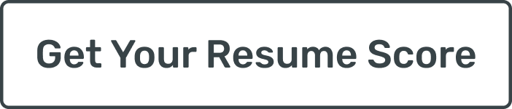
I wanted to personally thank you for choosing an Enhancv resume template while preparing your application.
Looking for a new role takes courage, focus, and persistence. You invested real effort into presenting your experience clearly and honestly, and that matters. A resume is more than a document. It reflects your choices, your priorities, and the work you stand behind.
If you would like to explore everything our platform offers, you can visit https://enhancv.com. There, you’ll have access to tools such as:
- Resume checks with real-time feedback
- ATS compatibility insights
- AI-powered content suggestions
- Cover letter creation and customization
- Role-specific guidance to improve clarity and impact
At Enhancv, we build tools for people who take their next step seriously. Seeing our templates and platform support job seekers like you is why we do this work.
Thank you for trusting us during an important moment in your career. I wish you confidence in your applications and success in the opportunities ahead.
Warm regards,
Volen Vulkov
Co-Founder


